课程名称＿＿数据结构＿ 实验名称＿实验14＿＿ 实验日期＿＿2019.5＿＿＿＿＿
班 级＿计科1805＿＿ 姓 名＿吕思颖＿＿ 学号＿1033180511＿＿ 仪器编号＿＿＿＿＿＿
实验报告要求 1.实验目的 2.实验要求 3.实验步骤 4.程序清单 5.运行情况 6.流程图 7.实验体会
实验目的：
⑴ 熟悉图的定义和基本操
⑵ 掌握图的邻接矩阵存储结构设
⑶ 掌握图的最短路径算法

实验内容：
1、采用书上第 161 页定义的图的邻接矩阵存储表示，编程实现产生最短路径的 Dijkstra 算法。
2、采用书上第 161 页定义的图的邻接矩阵存储表示，编程实现产生最短路径的的 Floyd 算法。

程序清单：
1.
#include <stdio.h>
#include <stdlib.h>
#include <limits.h>
#define TRUE 1
#define FALSE 0
#define OK 1
#define ERROR 0
#define OVERFLOW -2
#define INFINITY 32767
#define MAX_VERTEX_NUM 20
typedef int Status;
typedef int VRType;
typedef int InfoType;
typedef int PathMatrix[MAX_VERTEX_NUM][MAX_VERTEX_NUM];
typedef int ShortPathTable[MAX_VERTEX_NUM];
typedef enum { DG, DN, UDG, UDN }GraphKind;
typedef struct ArcCell
{
VRType adj;
InfoType *info;
}ArcCell, AdjMaxtrix[MAX_VERTEX_NUM][MAX_VERTEX_NUM];
typedef char VertexType;
typedef struct
{
VertexType vexs[MAX_VERTEX_NUM];
AdjMaxtrix arcs;
int vexnum, arcnum;
GraphKind kind;
}MGraph;
int D[MAX_VERTEX_NUM];
int LocateVex(MGraph G, char v)
{
int i;
for (i = 0; i < G.vexnum; ++i)
if (G.vexs[i] == v) return i;
return -1;
}
Status CreateDN(MGraph &G)
{

int i, j, k, w;
VertexType v1, v2;
printf("输入顶点数G.vexnum:");
scanf("%d", &G.vexnum);
printf("输入边数G.arcnum:");
scanf("%d", &G.arcnum);
getchar();
for (i = 0; i < G.vexnum; i++) {
printf("输入顶点G.vexs[%d]:", i);
scanf("%c", &G.vexs[i]);
getchar();
}
for (i = 0; i < G.vexnum; ++i)
for (j = 0; j < G.vexnum; ++j) {
G.arcs[i][j].adj = INFINITY;
G.arcs[i][j].info = NULL;
}
for (k = 0; k < G.arcnum; ++k)
{
printf("输入第%d条边vi,vj和vi->vj的权值w（int)\n", k + 1);
scanf("%c %c %d", &v1, &v2, &w);
getchar();
i = LocateVex(G, v1); j = LocateVex(G, v2);
G.arcs[i][j].adj = w;
}
return OK;
}
// Dijkstra算法
void ShortestPath_DIJ(MGraph G, int v0, PathMatrix &P, ShortPathTable &D)
{
int v, final[G.vexnum + 1], w, min, i, j;
for (v = 0; v < G.vexnum; ++v)
{
final[v] = FALSE;
D[v] = G.arcs[v0][v].adj;
for (w = 0; w < G.vexnum; ++w) P[v][w] = FALSE;
if (D[v] < INFINITY)
{
P[v][v0] = TRUE; P[v][v] = TRUE;
}
}
D[v0] = 0; final[v0] = TRUE;
for (i = 1; i < G.vexnum; ++i)
{
min = INFINITY;
for (w = 0; w < G.vexnum; ++w)
if (!final[w])
if (D[w] < min)
{
v = w; min = D[w];
}
final[v] = TRUE;
for (w = 0; w < G.vexnum; ++w)
if (!final[w] && (min + G.arcs[v][w].adj < D[w]))
{
D[w] = min + G.arcs[v][w].adj;
for (j = 0; j < G.vexnum; j++)
P[w][j] = P[v][j];
P[w][w] = TRUE;
}
}
for (i = 0; i < G.vexnum; ++i)
{
if (i != v0)
{
printf("%3c %3c", G.vexs[v0], G.vexs[i]);
if (D[i] != INFINITY)
printf("%5d ", D[i]);
else printf("%5s", "无");
printf("(");
for (j = 0; j < G.vexnum; ++j)
if (P[i][j]) printf("%c", G.vexs[j]);
printf(")");
printf("\n");
}
}
}

void list(MGraph G)
{
int i, j;
printf("输出邻接矩阵:\n");
for (i = 0; i < G.vexnum; ++i) {
printf("%c---", G.vexs[i]);
for (j = 0; j < G.vexnum; ++j)
if (G.arcs[i][j].adj == INFINITY)
printf("%4s", " ∞");
else
printf("%4d", G.arcs[i][j].adj);
printf("\n");
}
}
int main()
{
MGraph G;
int v0;
PathMatrix P;
ShortPathTable D;
CreateDN(G);
list(G);
printf("输入源点序号v0:");
scanf("%d", &v0);
printf("输出从源点%d到其余顶点的最短路径如下:\n", v0);
printf("始点 终点 路径长度 最短路径\n");
ShortestPath_DIJ(G, v0, P, D);
printf("\n");
}
2.
#include <stdio.h>
#include <stdlib.h>
#include <limits.h>
#define TRUE 1
#define FALSE 0
#define OK 1
#define ERROR 0
#define OVERFLOW -2
#define INFINITY 32767
#define MAX_VERTEX_NUM 20
typedef int Status;
typedef int VRType;
typedef int InfoType;
typedef enum { DG, DN, UDG, UDN } GraphKind;
typedef struct ArcCell {
VRType adj;
InfoType *info;
}ArcCell, AdjMaxtrix[MAX_VERTEX_NUM][MAX_VERTEX_NUM];
typedef char VertexType;
typedef struct {
VertexType vexs[MAX_VERTEX_NUM];
AdjMaxtrix arcs;
int vexnum, arcnum;
GraphKind kind;
}MGraph;
int LocateVex(MGraph G, char v) {
int i;
for (i = 0; i < G.vexnum; ++i)
if (G.vexs[i] == v) return i;
return -1;
}
Status CreateDN(MGraph &G) {
int i, j, k, w;
VertexType v1, v2;
printf("输入顶点数G.vexnum:");
scanf("%d", &G.vexnum);
printf("输入边数G.arcnum:");
scanf("%d", &G.arcnum);
getchar();
for (i = 0; i < G.vexnum; i++) {
printf("输入顶点G.vexs[%d]:", i);
scanf("%c", &G.vexs[i]);
getchar();
}
for (i = 0; i < G.vexnum; ++i)
for (j = 0; j < G.vexnum; j++) {
G.arcs[i][j].adj = INFINITY;
G.arcs[i][j].info = NULL;
}
for (k = 0; k < G.arcnum; ++k) {
printf("输入第%d条边vi,vj和vi->vj的权值w(int)\n", k + 1);
scanf("%c %c %d", &v1, &v2, &w);
getchar();
i = LocateVex(G, v1); j = LocateVex(G, v2);
G.arcs[i][j].adj = w;
}
return OK;
}
void ShortestPath_FLOYD(MGraph G) {
int P[G.arcnum + 1][G.arcnum + 1][G.arcnum + 1], D[G.arcnum + 1][G.arcnum + 1], v, w, u, i, j;
for (v = 0; v < G.vexnum; ++v)
for (w = 0; w < G.vexnum; w++) {
D[v][w] = G.arcs[v][w].adj;
for (u = 0; u < G.vexnum; ++u)
if (D[v][w] < INFINITY&&D[v][w] != 0) {
P[v][w][v] = TRUE; P[v][w][w] = TRUE;
}
}
for (u = 0; u < G.vexnum; ++u)
for (v = 0; v < G.vexnum; ++v)
for (w = 0; w < G.vexnum; ++w)
if (D[v][u] + D[u][w] < D[v][w]) {
D[v][w] = D[v][u] + D[u][w];
for (i = 0; i < G.vexnum; ++i)
P[v][w][i] = P[v][u][i];
}
for (i = 0; i < G.vexnum; i++)
for (j = 0; j < G.vexnum; j++)
if (D[i][j] != 9)
printf("%c到%c的最短路径为:%d\n", G.vexs[i], G.vexs[j], D[i][j]);
}
int main() {
printf("构造有向网G:\n");
MGraph G;
CreateDN(G);
printf("FLOYD算法求最短路径！\n");
ShortestPath_FLOYD(G);
}
运行情况：
2.
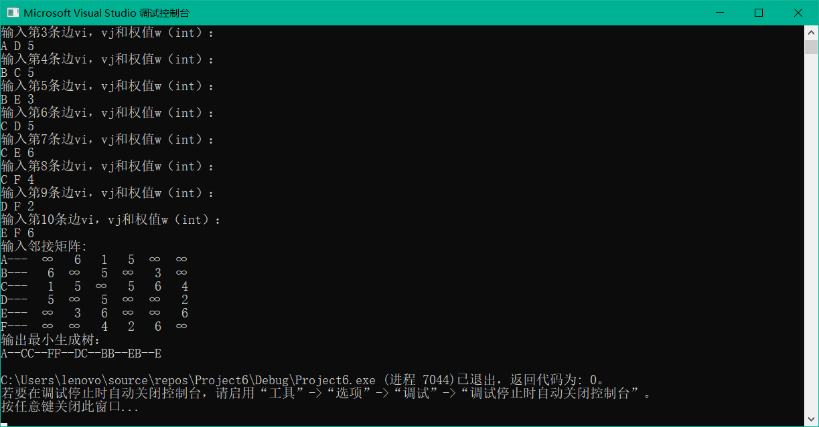
实验体会：第一题不是很会做
教师评价 | 优 |  | 良 |  | 中 |  | 及格 |  | 不及  格 |  | 教师签名 |  | 日期
江南大学物联网工程学院实验报告

